A Mini Project Report
On
JJ FURNITURE WORLD
Submitted in partial fulfillment of the
requirements for the award of degree of

Bachelor of Technology
In
Computer Science and Engineering
By
J Aishwarya,
(14H61A0578)
Sameer,
(14H61A0594)
K Ramya,
(14H61A0582)
Under the Guidance of
Dr.G.Vishnu Murthy
Head, Dept. of CSE


ANURAG GROUP OF INSTITUTIONS
(Formerly CVSR College of Engineering)
(An Autonomous Institution, Approved by AICTE and NBA Accredited)
Venkatapur (V), Ghatkesar (M), RR Dist., T.S-500088
(2014-2018)
Department of Computer Science and Engineering


ANURAG GROUP OF INSTITUTIONS
(Formerly CVSR College of Engineering)
(An Autonomous Institution, Approved by AICTE and NBA Accredited)
Venkatapur (V), Ghatkesar (M), RR Dist., T.S-500088
Department of Computer Science and Engineering

CERTIFICATE

This is to certify that the project entitled “JJ FURNITURE WORLD” being submitted by J Aishwarya bearing the Hall Ticket number 14H61A0578, Sameer bearing the Hall Ticket number 14H61A0594 and K Ramya bearing the Hall Ticket number 14H61A0582 in partial fulfillment of the requirements for the award of the degree of the Bachelor of Technology in Computer Science and Engineering to Anurag Group of Institutions (Formerly CVSR College of Engineering) is a record of bonafide work carried out by them under my guidance and supervision from July 2017 to October 2017.
The results presented in this project have been verified and found to be satisfactory. The results embodied in this project report have not been submitted to any other University for the award of any other degree or diploma.

Internal Guide External Examiner
Dr.G.Vishnu Murthy,
Head, Dept. of CSE

Project Coordinator
Pallam Ravi
Asst. Professor

Dr.G.Vishnu Murthy,
Head, Dept. of CSE

ACKNOWLEDGEMENT

It is our privilege and pleasure to express profound sense of respect, gratitude and indebtedness to our guide Dr.G.Vishnu Murthy, Head of Department of computer science engineering, Anurag Group of Institutions (Formerly CVSR College of Engineering), for his indefatigable inspiration, guidance, cogent discussion, constructive criticisms and encouragement, suggestions, motivation and co-operation throughout this dissertation work and for the successful completion of the work.

We extend our sincere thanks to Dr.K.S.Rao, Director, Dr.V.Vijaya Kumar, Dean, Dept. of CSE & IT, Anurag Group of Institutions (Formerly CVSR College of Engineering), Venkatapur (V), Ghatkesar (M), Ranga Reddy (Dist), for their encouragement.

J Aishwarya (14H61A0578),
Sameer (14H61A0594),
K Ramya (14H61A0582).

,

DECLARATION

We hereby declare that the project work entitled “ JJ Furniture World” submitted to the Anurag Group of Institutions(Formerly CVSR College of Engineering) in partial fulfillment of the requirements for the award of the degree of Bachelor of Technology (B.Tech) in Computer Science and Engineering is a record of an original work done by us under the guidance of Dr.G.Vishnu Murthy, Head of Department of computer science engineering, and this project work have not been submitted to any other university for the award of any other degree or diploma.

J Aishwarya (14H61A0578),
Sameer (14H61A0594),
K Ramya (14H61A0582).

Date:

CONTENTS
Abstract page no.
- Introduction………………………………………………………………….. 07
1.1 Objective…………………………………………………………………..... 07
1.2 Scope ……………………………………………………………………… 08
1.3 Features……………………………………………………………………. 08
- Existing System………………………………………………………………. 09
- Problem Statement……………………………………………………………. 09
- Proposed System……………………………………………………………… 10
- Technologies Used……………………………………………………………. 11
- Design………………………………………………………………………… 12
6.1 Actors…………………………………………………………………….…. 12
6.2 Modules……………………………………………………………………...13-14
- UML Diagrams……………………………………………………………… 15-19
- Implementation.………………………………………………………………. 20-27
- Testing….………………………………………………………………...…... 27-30
- Screen shots.…………………………………………………………………...31-36
- Deployment…………………………………………………………………….. 37
- Conclusion and Future Enhancements…………………………………….……38
- Bibliography…………………………………………………………………….39

ABSTRACT

The title of the project is "Online furniture store (JJ World)". It is a web application that provides various categories of furniture, as furniture is what turns your house into a home.
The main aim of this project is it allows the user to buy the furniture online. This project will be very much helpful for the present generation as they can obtain their desire furniture without leaving the comfort of their home. It helps the customer to automate and facilitate the whole process of shopping.
USER MODULE:
The website consists of different categories of furniture of various designs and models. The customer who want to purchase a product can browse through the given products as per categories and can add the products into the cart. After adding the all the products they can make a booking of all the products by filling the form which consists of the name of the customer, user id of the customer, phone number and address of the customer.
Once the booking has been done the customer gets a message about the product he/she booked.
ADMIN MODULE:
The administrator manages the database which consists of information regarding the products and can view/add/delete the products. He can also view the customer bookings.
Thus, this online furniture shopping store brings an entire furniture shop online and makes it easy for both buyer and seller.

- INTRODUCTION

Furniture is what turns your house into a home. Nowadays, shopping online is occupying an essential part of shopping, big and small companies or stores need have its commercial website. Our project is a web-based application. It helps the customer to automate and facilitate the whole process of shopping. This application also has many features like the customer can browse through different varieties of products and can make booking of that product. Then the customer will receive an email regarding their booking. The overall application is developed in PHP (Hyper Text Pre- Processor), HTML, CSS.

  - OBJECTIVE

The main objective of this project is to provide the customer an easy way to book the furniture online.
There are countless reasons to buy furniture, but the most important one is- the furniture is the backdrop to our lives. We need furniture for more comfort.
In this cosmopolitan environment our house is an expression of our personality. It reflects our status. It also expresses our sense of style. To maintain this, we need furniture because furniture makes our house look beautiful. But this present generation which has money but lack of time can’t go to the furniture shop to buy furniture. It is tedious and time-consuming process. In this technical world everything we want online.
By keeping these points in mind, we have developed this online furniture portal.
This project will be very much helpful for the present generation. Now they can obtain their desired furniture without stepping out of the door and also provides business enhancement for the vendor.

  - SCOPE

The scope of the project is to provide a very easy way for the customers to browse across different varieties of products based on categories and make a booking of those products which they require in their home without stepping out of the door. This is done with web technology to automate and facilitate the whole process of shopping.

  - FEATURES

The main features of this project are:
- The site consists manages product catalogue with product image, product price and quantity.
- The site is designed with vibrant colors and backgrounds and different types of designs on same screen.
- It also consists of cart, which consists of the products that the customer wants to buy with the total price of all the products that the customer added to cart.
- After making a booking of the product customer also receives a confirmation email about the product they booked.
- The admin can view all the details of the products that the customer booked with their phone number, name and address.
- It also consists of a google map pointing to the store location.
- It is very simple and easy to use.

- EXISTING SYSTEM

There are so many furniture websites with advanced features. But this website is designed for a store located in another place.
Disadvantages:
- In the existing system, the customer visits the store and select from available products.
- Limited number of products will be available due to space constraints
- There is no guarantee that they can find their desired product with their expected price.

- PROBLEM STATEMENT

The furniture in a home is like the meat and potatoes of a meal. Our furniture takes up the majority of space and helps make your home feel lived in, welcoming and complete. So, when someone wants to buy a furniture they need to find the store and then visit the store to purchase the product. So, we developed this site for the customers to book a product easily without leaving the comfort of their home, with all the details of the product like image and price.

- PROPOSED SYSTEM

In the proposed system, the user overcomes the disadvantages in existing system by using this “JJ FURNITURE WORLD” website. This Proposed system is very must timely and suitable.
The user opens the web site and view all the furniture available along with the information like images, price etc. which is a great help to the customer.
If user likes any product it can be added to his shopping cart. Once all the desired products are added to the cart user can book the order online.
User can view list of available furniture with the proper description and cost. User can search the furniture based on different categories.
User can select and book his/her desired product. Admin is responsible to deliver the product to his address.
Admin is responsible to add various type of furniture to the portal based on different categories and price. Admin can view list of furniture available in to the database and also, he can view list of order placed by the customers.
Advantages:
- Allows the customer to automate and facilitate the whole process of shopping.
- Customer can browse as many furniture designs across categories and can filter, compare options, easily select and book the ones they like.
- They will always stay updated about new and contemporary designs.
- Shopping can be done without stepping out of the door.

- TECHNOLOGIES USED

  - SOFTWARE INTERFACES:

We use Java as Programming language for writing the code for the project. SQLite
database server is used for creating the local and global database (server). Notepad++ for
writing the programs. Operating system will be Windows 10.

- Software Requirements:

- Front end:
- HTML
- JAVASCRIPT
- CSS
- Back end:
- PHP
- MySQL

- Hardware Requirements:

1. RAM : 1GB Ram or above.
2. Hard Disk : 80GB or above.
3. Processor : Dual core or above.

- DESIGN

  - ACTORS:
An actor is behavioral classifier which specifies a role played by an external entity that interacts with the subject (e.g., by exchanging signals and data), a human user of the designed system, some other system or hardware using services of the subject.

There are two actors. They are:
- Administrator
- User

ACTOR | DESCRIPTION
Administrator | - Manage the Database.  - View products.  - Add products.  - Delete products.  - View customer bookings
User | - Can browse across the products.  - Can add the products into the cart.  (Multiple products can be added at a time.)  - Make a booking of those products.

  - MODULES:

- User Module:
The user can browse across various categories of furniture of various designs and models as per categories and can add the products into the cart. After adding the all the products, they can make a booking of all the products by filling the form which consists of the name of the customer, user id of the customer, phone number and address of the customer.
Once the booking has been done the customer gets a message about the product he/she booked.
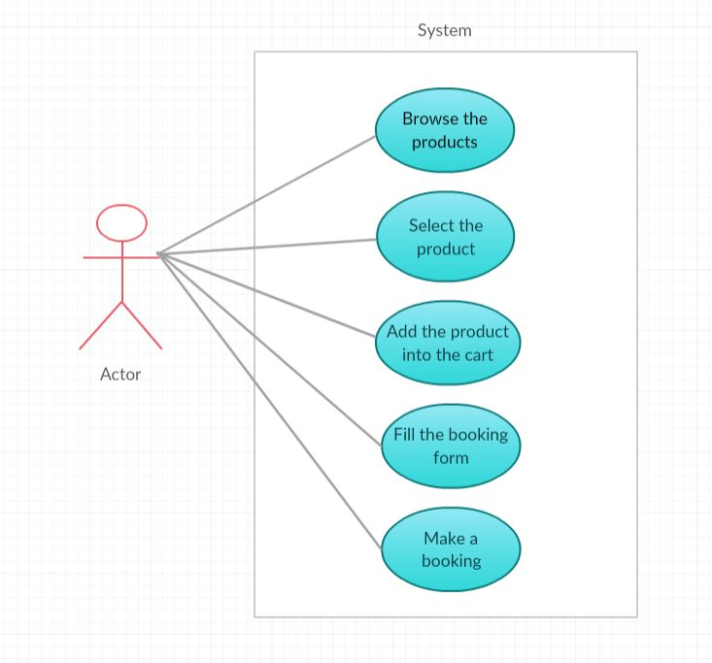

- Admin Module:
The administrator manages the database which consists of information regarding the products and can view/add/delete the products. He can also view the customer bookings.

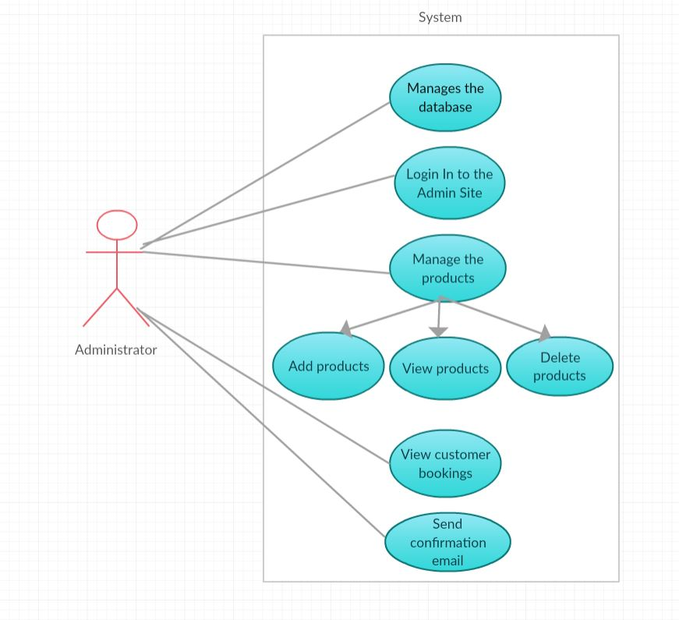

- UML DIAGRAMS

UML is a way of visualizing a software program using a collection of diagrams.
UML is a common language for business analysts, software architects and developers used to describe, specify, design, and document existing or new business processes, structure and behavior of artifacts of software systems.
UML is general purpose visual modelling language that is used to
- Document
- Specify
- Visualize
- Construct

Types of UML Diagrams:

Structural UML diagrams are:
- Class diagram.
- Object diagram.
- Component diagram.
- Deployment diagram.
Behavioural UML diagrams:
- Use case diagram.
- Sequence diagram.
- Collaboration diagram.
- State chart diagram.
- Activity diagram.

CLASS DIAGRAM:
A class diagram in the Unified Modelling Language (UML) is a type of static structure diagram that describes the structure of a system by showing the system's classes, their attributes, operations (or methods), and the relationships among objects. The class diagram is the main building block of object-oriented modelling.
In the diagram, classes are represented with boxes that contain three compartments:
- The top compartment contains the name of the class.
- The middle compartment contains the attributes of the class.
- The bottom compartment contains the operations the class can execute.

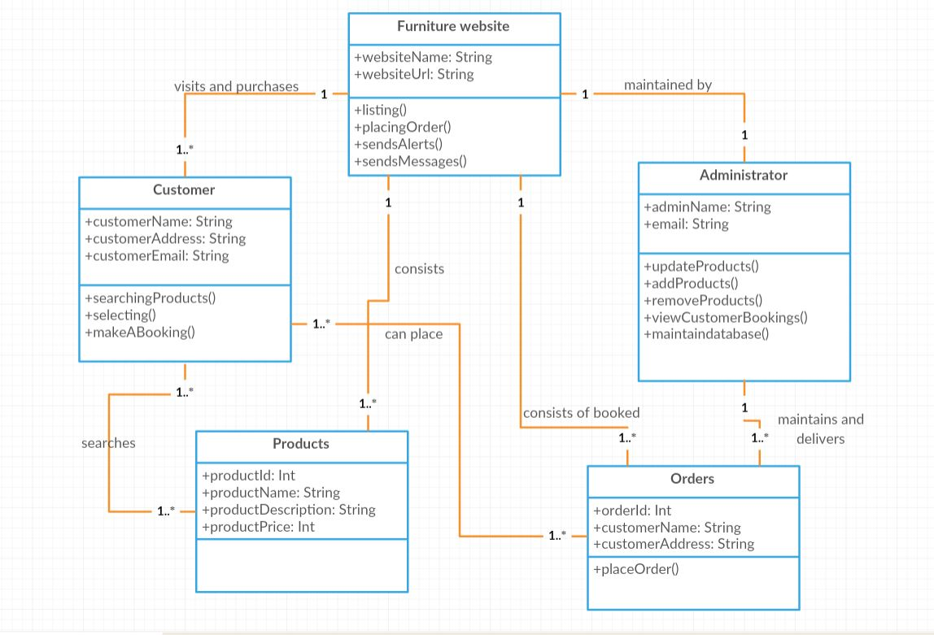
USE CASE DIAGRAM:
- A use case is a list of actions or event steps, typically defining the interactions between a role and a system, to achieve a goal.
- Use case diagrams are a set of use cases, actors, and their relationships. They represent the use case view of a system.
- A use case represents a particular functionality of a system. Hence, use case diagram is used to describe the relationships among the functionalities and their internal/external controllers. These controllers are known as actors.

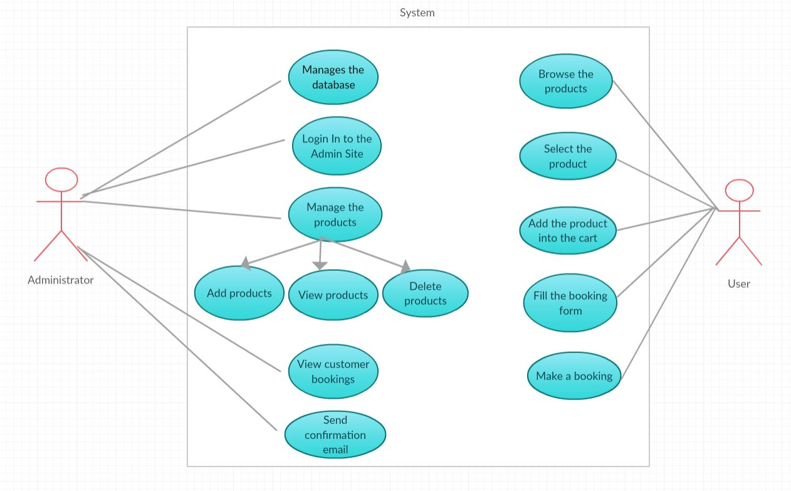

SEQUENCE DIAGRAM:
- A sequence diagram is an interaction diagram that shows how objects operate with one another and in what order. It is a construct of a message sequence chart.
- A sequence diagram shows, as parallel vertical lines (lifelines), different processes or objects that live simultaneously, and, as horizontal arrows, the messages exchanged between them, in the order in which they occur.
- Interaction among the components of a system is very important from implementation and execution perspective. Sequence diagram is used to visualize the sequence of calls in a system to perform a specific functionality.

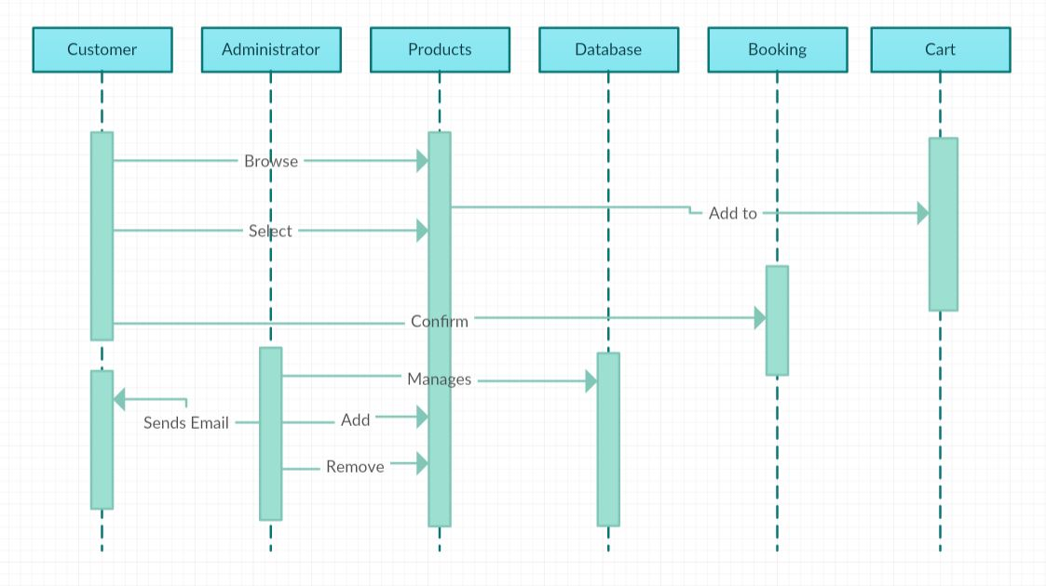

ACTIVITY DIAGRAM:
- An activity diagram visually presents a series of actions or flow of control in a system similar to a flowchart. Activity diagrams are often used in business process modelling. They can also describe the steps in a use case diagram. Activities modelled can be sequential and concurrent.
- Activities are nothing but the functions of a system. Numbers of activity diagrams are prepared to capture the entire flow in a system.

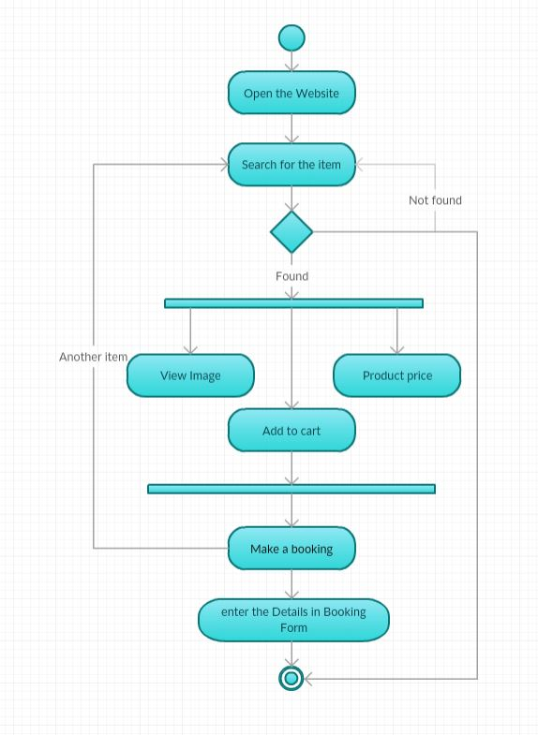
- IMPLEMENTATION

  - WEB TECHNOLOGY:
    - HTML & CSS:
Hypertext Markup Language (HTML) is the standard markup language for creating web pages and web applications. With Cascading Style Sheets (CSS), and JavaScript, it forms a triad of cornerstone technologies for the World Wide Web. Web browsers receive HTML documents from a webserver or from local storage and render them into multimedia web pages. HTML describes the structure of a web page semantically and originally included cues for the appearance of the document.
HTML elements are the building blocks of HTML pages. With HTML constructs, images and other objects, such as interactive forms may be embedded into the rendered page. It provides a means to create structured documents by denoting structural semantics for text such as headings, paragraphs, lists, links, quotes and other items.
HTML elements are delineated by tags, written using angle brackets. Tags such as <img /> and <input /> introduce content into the page directly. Others such as <p>...</p> surround and provide information about document text and may include other tags as sub-elements. Browsers do not display the HTML tags, but use them to interpret the content of the page.
Cascading Style Sheets (CSS) is a style sheet language used for describing the presentation of a document written in a markup language. Although most often used to set the visual style of web pages and user interfaces written in HTML and XHTML, the language can be applied to any XML document, including plain XML, SVG and XUL, and is applicable to rendering in speech, or on other media. Along with HTML and JavaScript, CSS is a cornerstone technology used by most websites to create visually engaging webpages, user interfaces for web applications, and user interfaces for many mobile applications.
CSS is designed primarily to enable the separation of document content from document presentation, including aspects such as the layout, colors, and fonts.

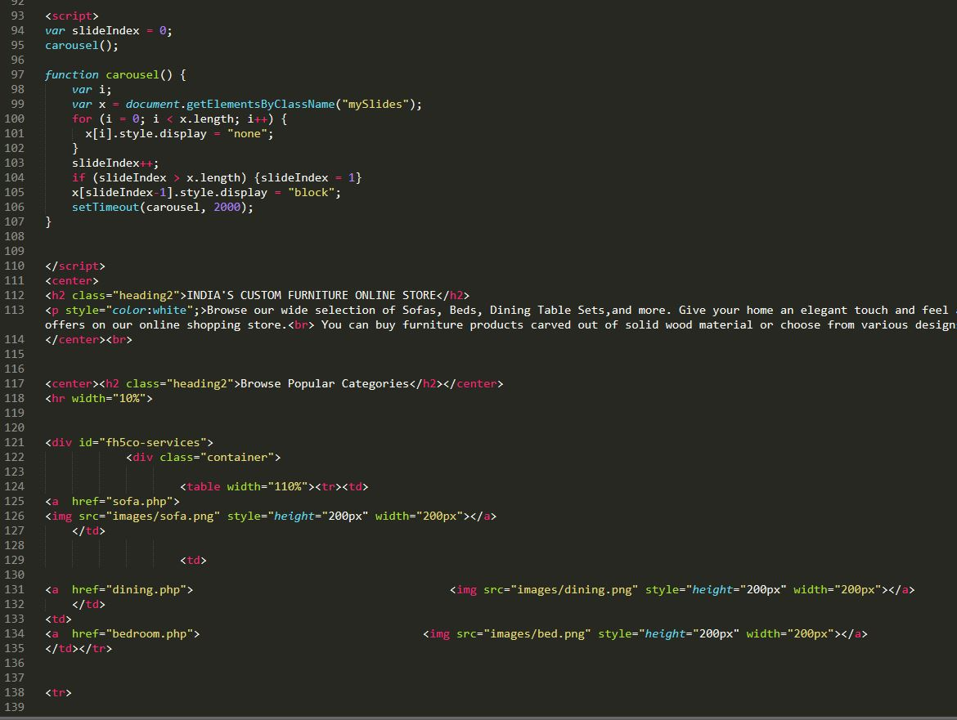
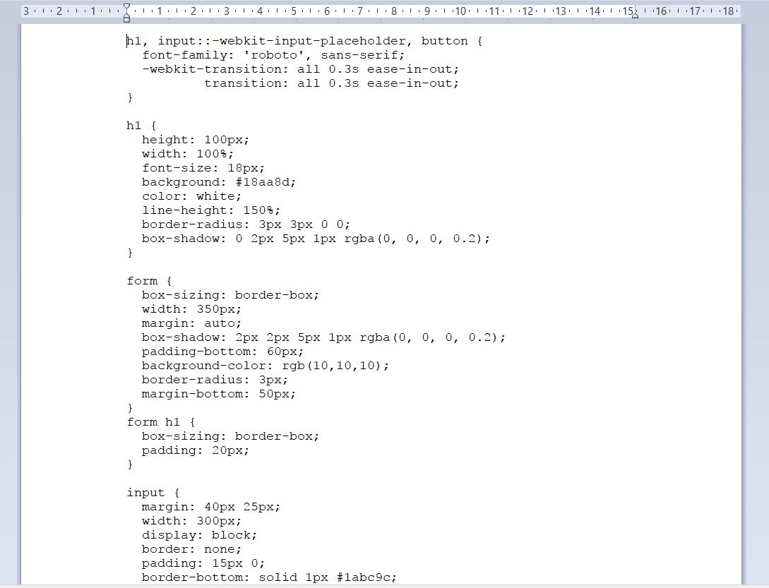
8.1.2 PHP
PHP is a server-side scripting language designed primarily for web development but is also used as a general-purpose programming language. Originally created by Rasmus Lerdorf in 1994, the PHP reference implementation is now produced by The PHP Development Team. PHP originally stood for Personal Home Page, but it now stands for the recursive acronym PHP: Hypertext Preprocessor.
PHP code may be embedded into HTML code, or it can be used in combination with various web template systems, web content management systems and web frameworks. PHP code is usually processed by a PHP interpreter implemented as a module in the web server or as a Common Gateway Interface (CGI) executable.
The web server combines the results of the interpreted and executed PHP code, which may be any type of data, including images, with the generated web page. PHP code may also be executed with a command-line interface (CLI) and can be used to implement standalone graphical applications.
    - Web Development Kit:
Web development tools allow web developers to test and debug their code. Web development tools come as browser add-ons or built in features in web browsers. The most popular web browsers today like, Google Chrome, Firefox, Opera, Internet Explorer, and Safari have built in tools to help web developers, and many additional add-ons can be found in their respective plugin download centers.
Notepad++ is a text editor and source code editor for use with Microsoft Windows. Unlike Notepad, the built-in Windows text editor, it supports tabbed editing, which allows working with multiple open files in a single window. The project's name comes from the C increment operator.
Sublime Text is a sophisticated text editor for code, markup and prose. Sublime Text automatically generates a project-wide index of every class, method and function.

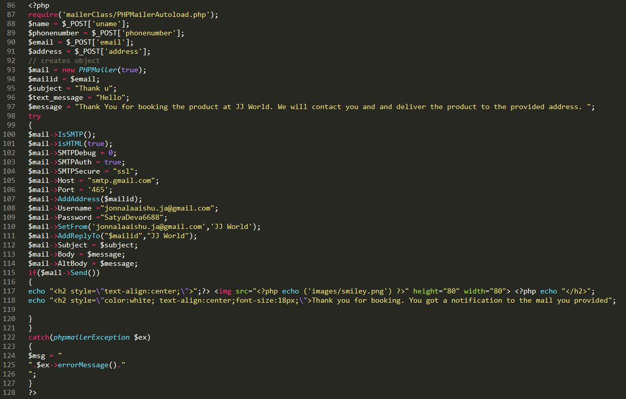
  - SOURCE CODE STRUCTURE:

    - FOLDERS:

- CSS: It is the folder that contains all the “.css” files that are created to provide styling to the website.

- FONTS: It is a folder which consists of different types of fonts that are used in the website.

- IMAGES: It is a folder which consists of all the images that are used in the website.

- JS: Folder that consists of all the java script files i.e. “.js” files.

- MAILER CLASS: It is a folder that consists of all the files which are used while sending an confirmation email to the user through Gmail after making a booking of the product.

    - FILES:

- mail.php: It is a file that consists of code that sends a confirmation email to the customer after making a booking of the product.

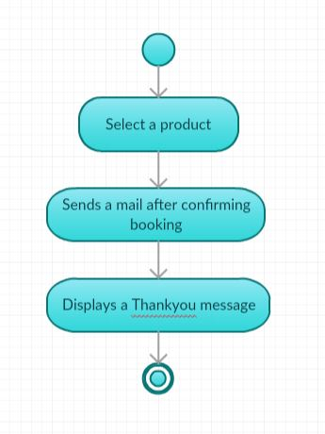

- Form.php: It is a file that consists of code, where the customer will fill his/her details and confirm booking.
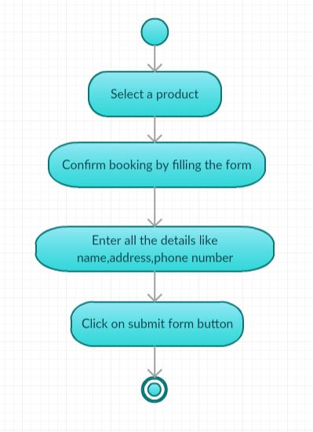

- index.php: It contains the source code for the landing page of the website.

- sofa.php, bedroom.php, dining.php, electronic.php, wardrobe.php: These are all the files which consists of code to retrieve the products from database and display the products based on category.

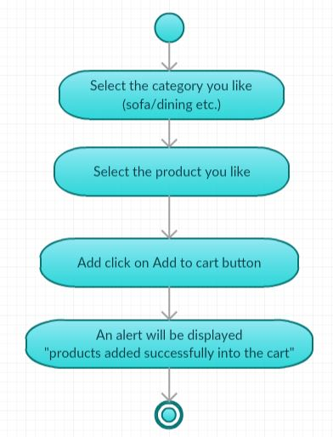
- shoppingbag.php: It consists the code to display all the products that are been added into the cart with total amount price and quantity.

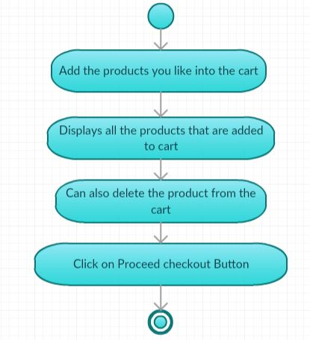

- adminlogin.php: It consists of the code used to login into the admin site.

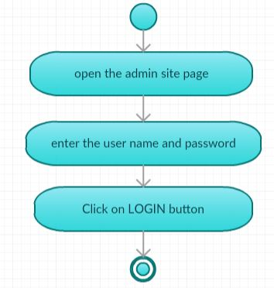

- admin.php: It consists of the code to insert products i.e. product name, product image, product id, product price and category into the database.

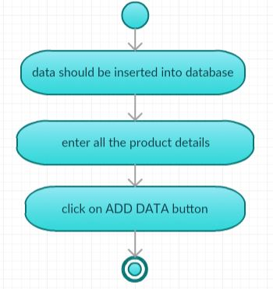

- productsdisplay.php: It consists of the code to display all the products which are present in database and products can also be deleted.

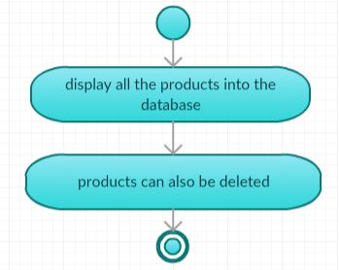
- bookedproducts display: It consists of the code which is used to display all the products that the customer booked with customer name, email, address and phone number.

- contact.php: It consists of the code to display the information about the store and location of the store using google maps.

- TESTING

  - INTRODUCTION:

The purpose of testing is to discover errors. Testing is the process of trying to discover every conceivable fault or weakness in a work product. It provides a way to check the functionality of components, sub-assemblies, assemblies and/or a finished product. It is the process of exercising software with the intent of ensuring that the software system meets its requirements and user expectations and does not fail in an unacceptable manner. There are various types of test. Each test type addresses a specific testing requirement.

  - OBJECTIVES OF TESTING:

- Finding defects which may get created by the programmer while developing the software.
- Gaining confidence in and providing information about the level of quality.
- To prevent defects.
- To make sure that the end result meets the business and user requirements.
- To ensure that it satisfies the BRS that is Business Requirement Specification and SRS that is System Requirement Specifications.
- To gain the confidence of the customers by providing them a quality product.

  - TYPES OF TESTING:
There are many approaches available in software testing.

- BLACK BOX TESTING:
Black box testing is a testing technique that ignores the internal mechanism of the system and focuses on the output generated against any input and execution of the system. It is also called functional testing. Black box testing is often used for validation.

- WHITE BOX TESTING:
White box testing is a testing technique that takes into account the internal mechanism of a system. It is also called structural testing and glass box testing.
white box testing is often used for verification.

- UNIT TESTING:

Unit testing is the testing of an individual unit or group of related units. It falls under the class of white box testing. It is often done by the programmer to test that the unit he/she has implemented is producing expected output against given input.

- INTEGRATION TESTING:

Integration testing is testing in which a group of components are combined to produce output. Also, the interaction between software and hardware is tested in integration testing if software and hardware components have any relation. It may fall under both white box testing and black box testing.

- FUNCTIONAL TESTING:

Functional testing is the testing to ensure that the specified functionality required in the system requirements works. It falls under the class of black box testing.

- SYSTEM TESTING:

System testing is the testing to ensure that by putting the software in different environments (e.g., Operating Systems) it still works. System testing is done with full system implementation and environment. It falls under the class of black box testing.

- VALIDATION TESTING:

This testing concentrates on confirming that the software is error-free in all respects. All the specified validations are verified and the software is subjected to hard-core testing. It also aims at determining the degree of deviation that exists in the software designed from the specification; they are listed out and are corrected.

- PERFORMANCE TESTING:

Performance testing is the testing to assess the speed and effectiveness of the system and to make sure it is generating results within a specified time as in performance requirements. It falls under the class of black box testing.

Test Case ID | Test Case | Function being Tested | Initial state | Input | Output | Status
1. | Select Category | Verify category page. | Category page | - | Products display | Successful
2. | Select products | Verify products | Category page | - | Products added to cart | Successful
3. | Select cart | All the selected products - added to cart/not. | Cart page | Select the products you like. | Selected products and total amount | Successful
4. | form | All the details entered are stored in database or not. | Form page | Name, email, address, phonenumber and confirm booking. | ThankYou page and confirmation email will be sent. | Successful
Test Case ID | Test Case | Function being tested | Initial state | Input | Output | Status
1. | Login | Verify Username and password. | Login page | Username and password | Admin homepage | Successful
2. | Adding products to database. | Products are getting added /not. | Insert into database page | Details about the product. | Added to database | Successful
3. | Display products | All the products are display/not and are deleted/not | Display products page | - | Displaying products. | Successful
4. | Booked products | Information about booked products is retrieved or not. | Booked products page | - | Display details of customer and products. | Successful
- SCREEN SHOTS

- Index Page:

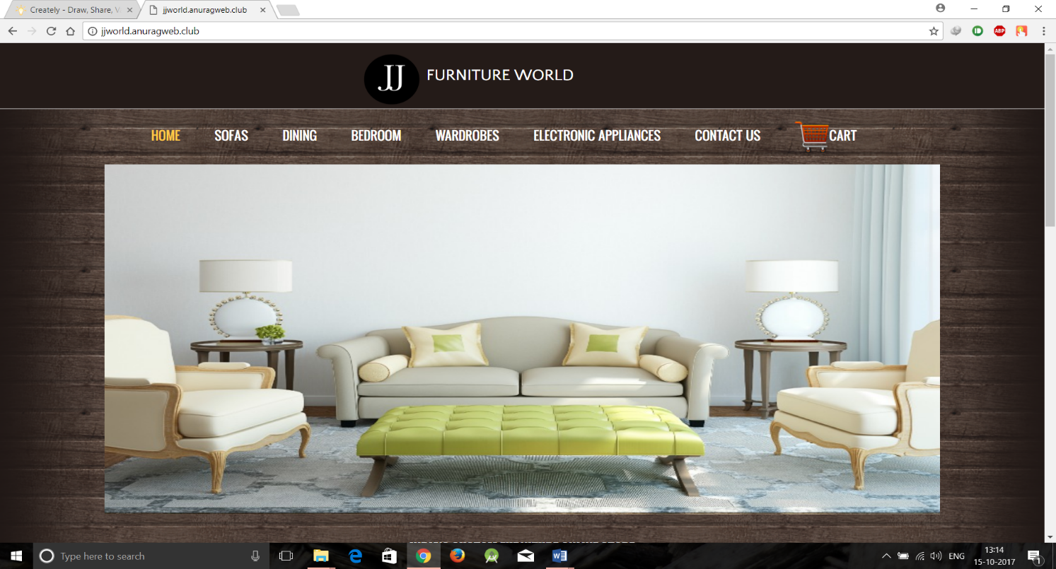

- Category pages:

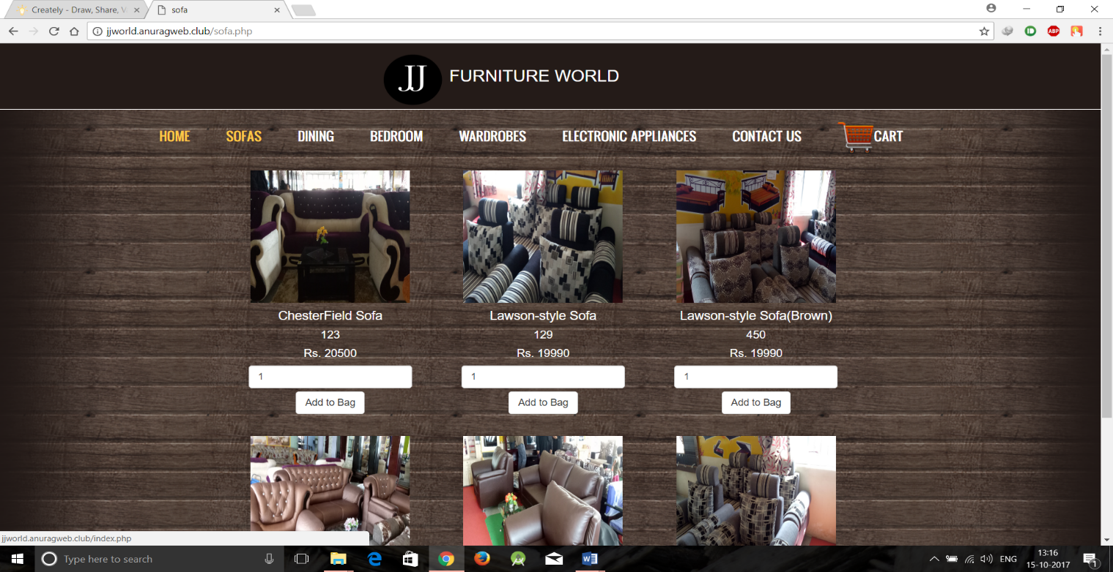
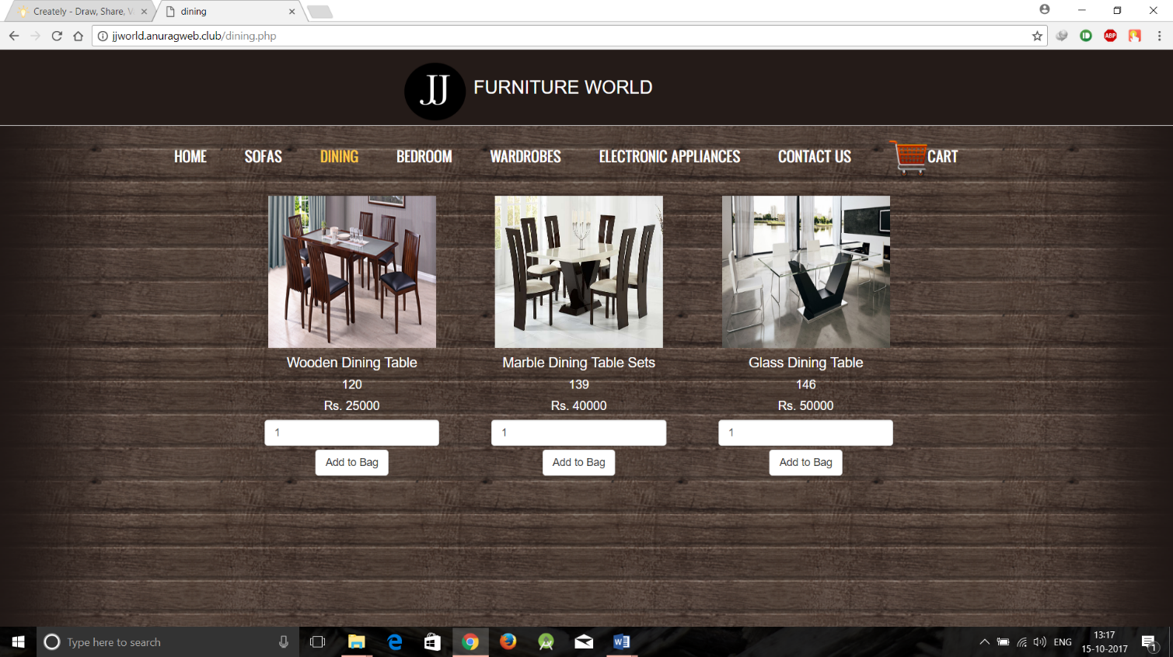
- Cart page:

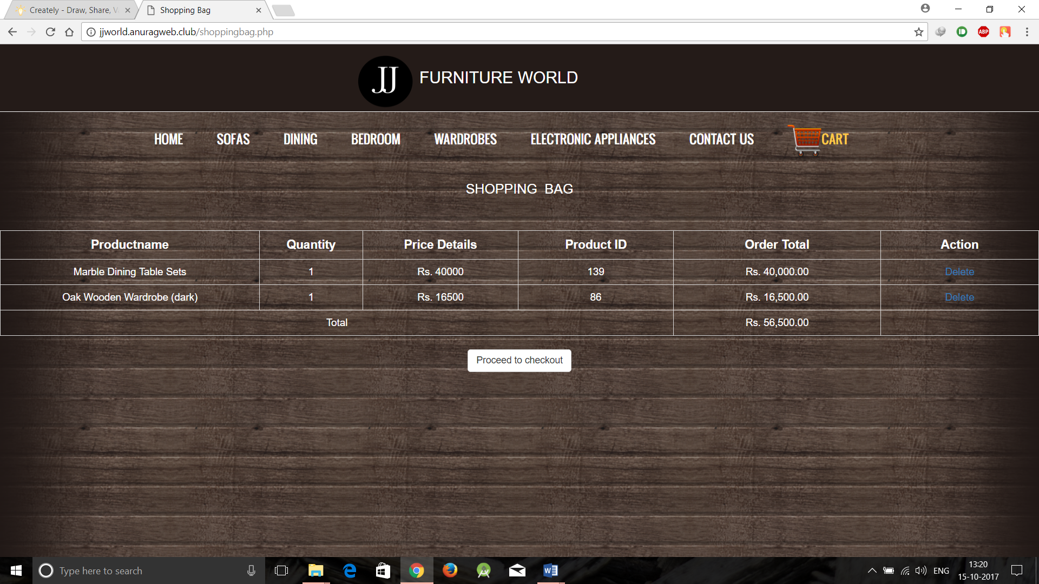

- Form page:

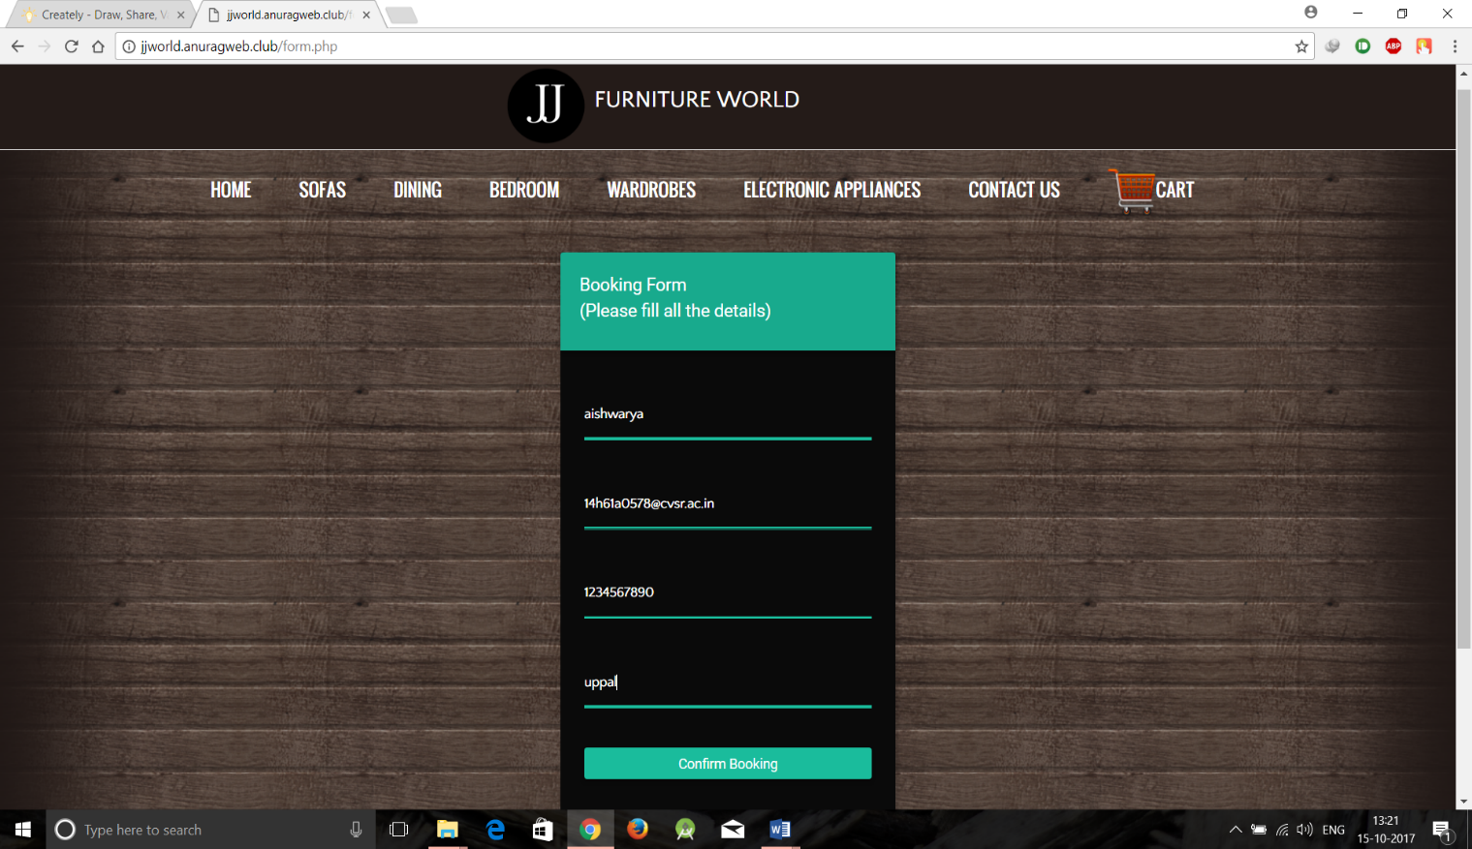

- Thank you page:

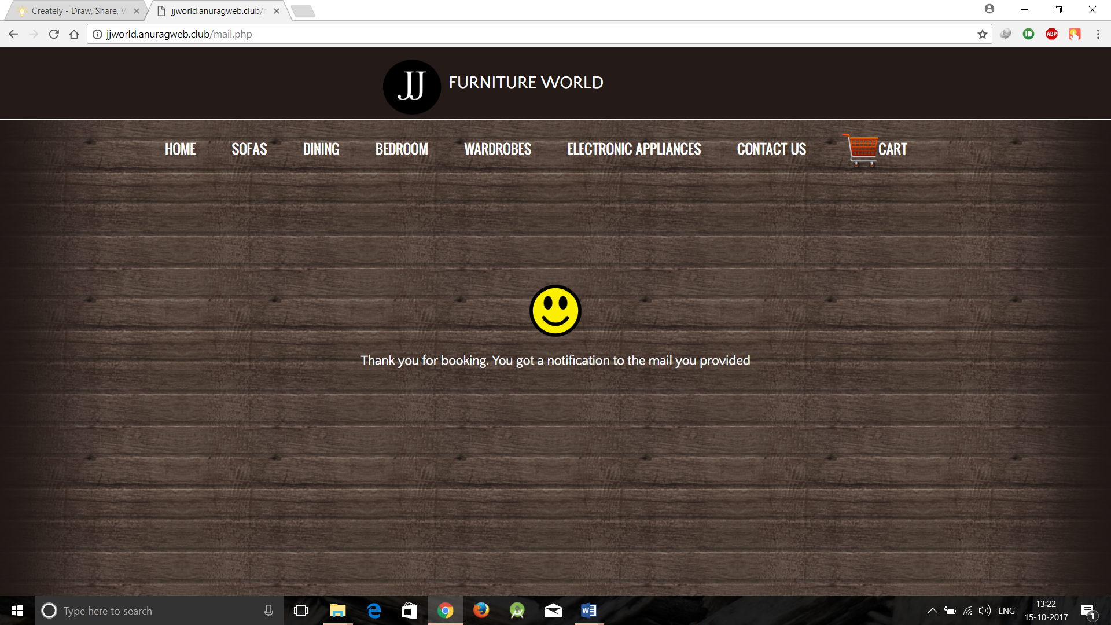

- Confirmation Email:

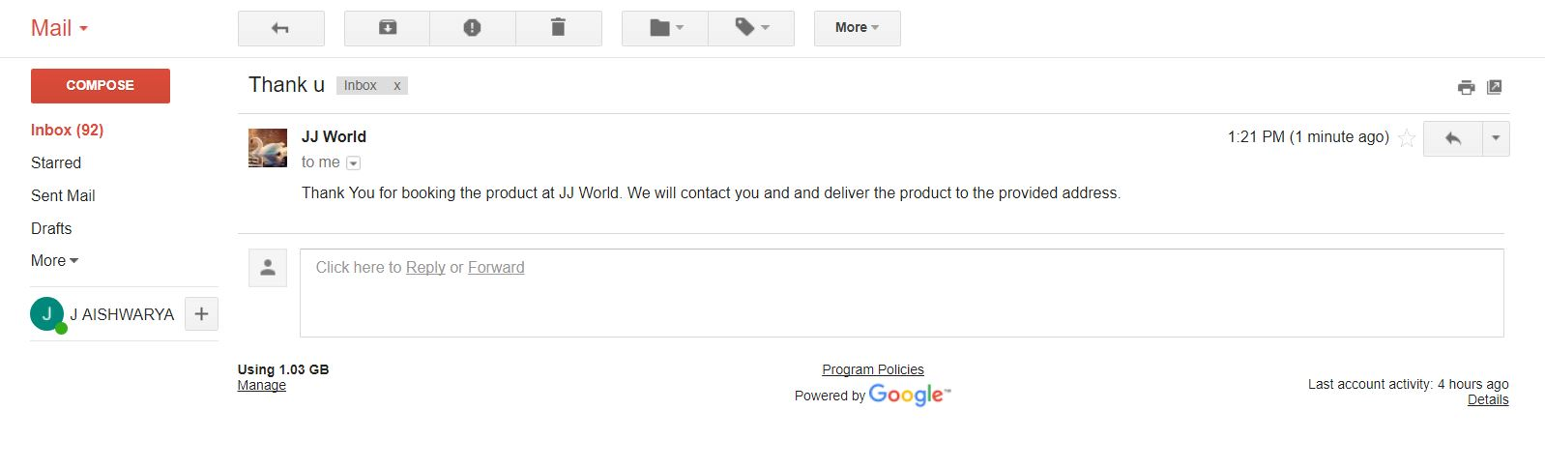
- Admin Login:

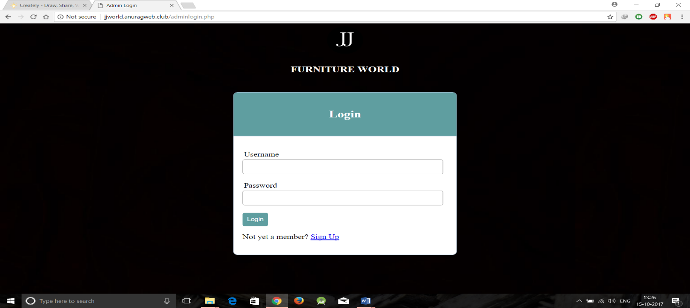

- Inserting Data into Database:

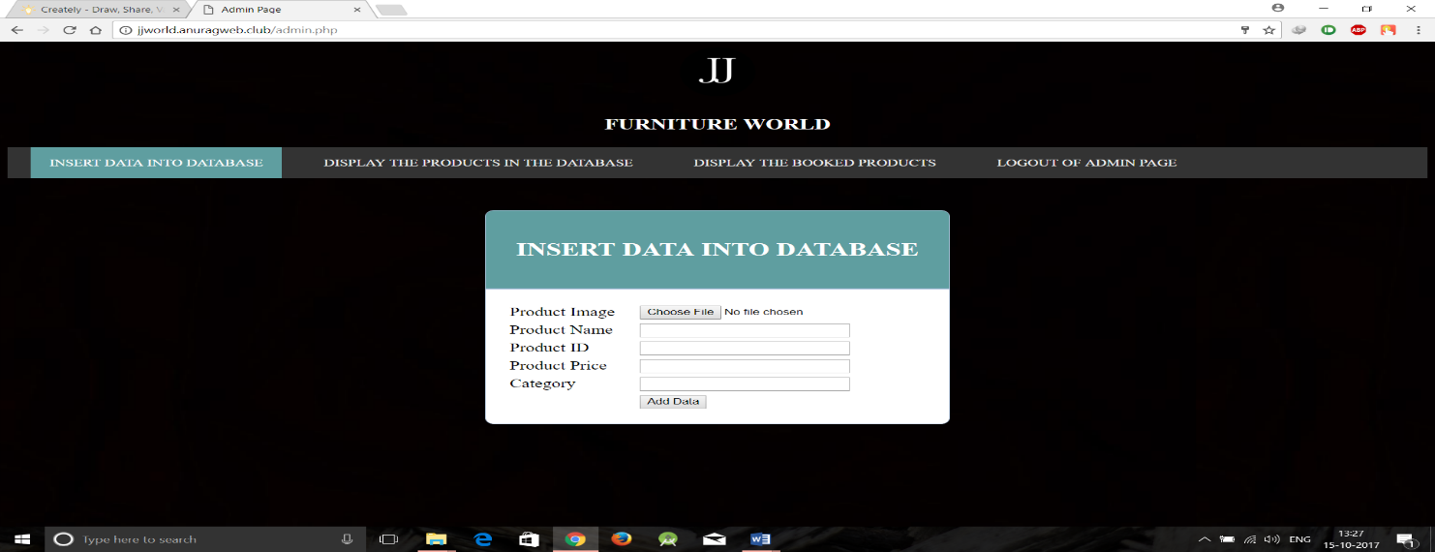

- Displaying the products in the database:

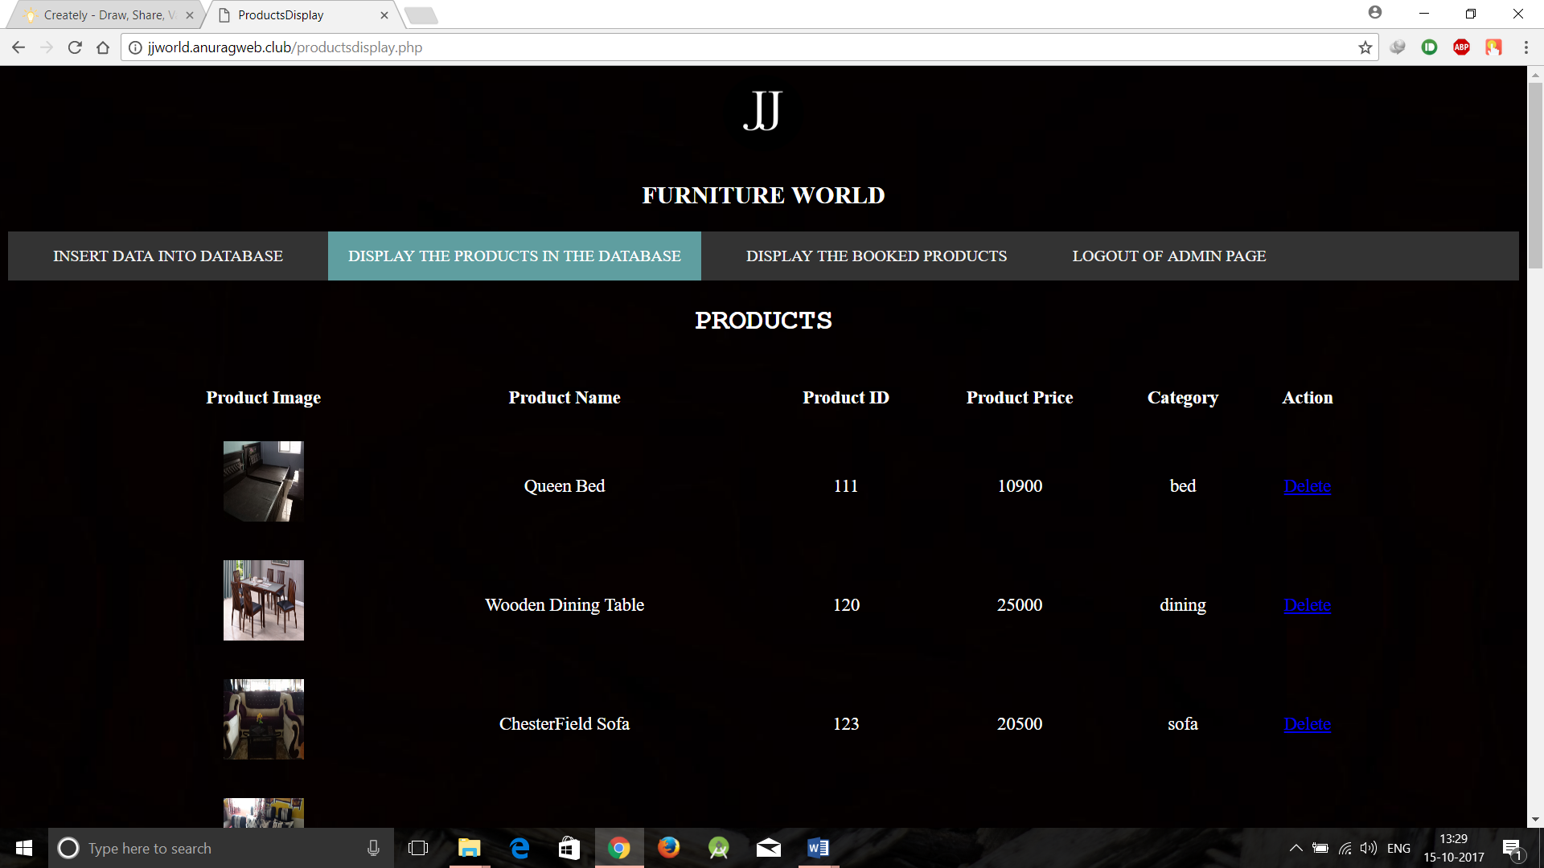

- Details about Booked products:

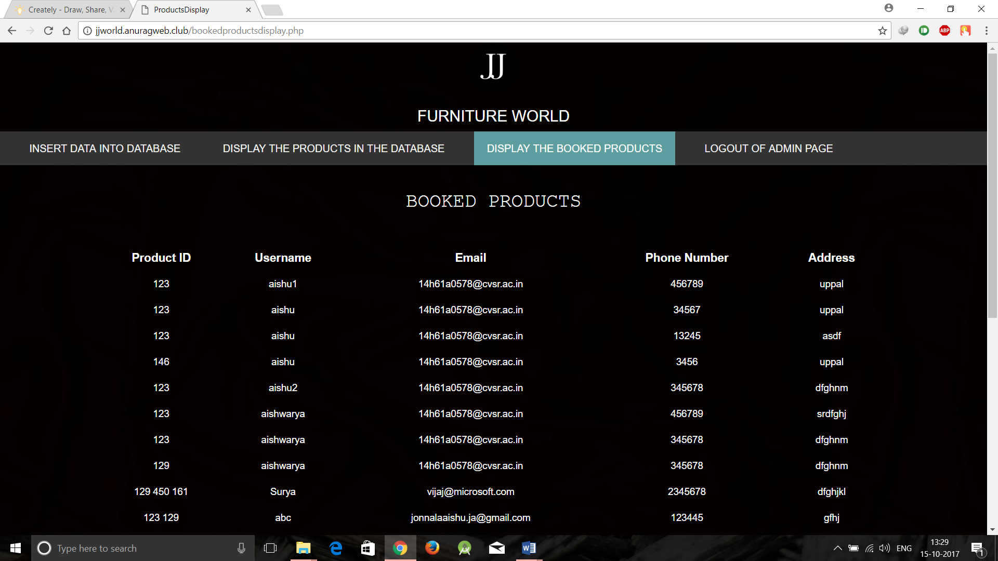

- Tables in PHP MyAdmin:

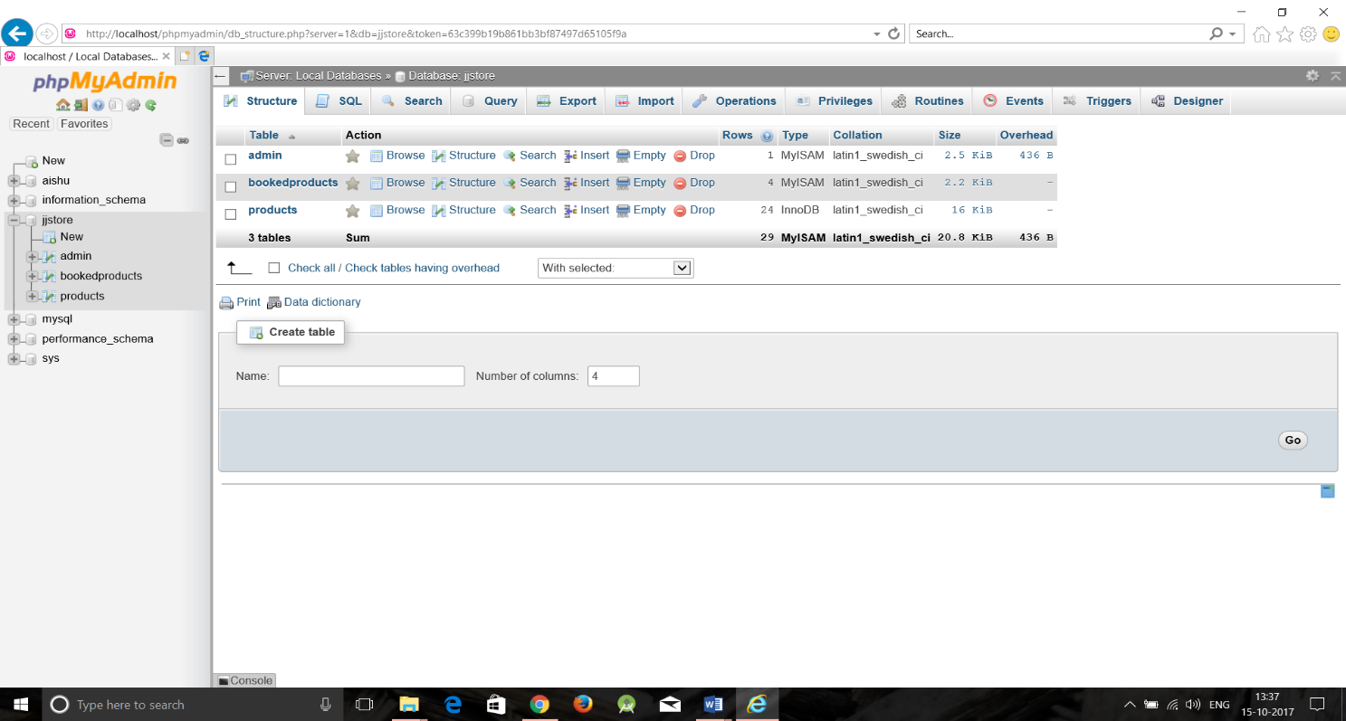

- Products Table:

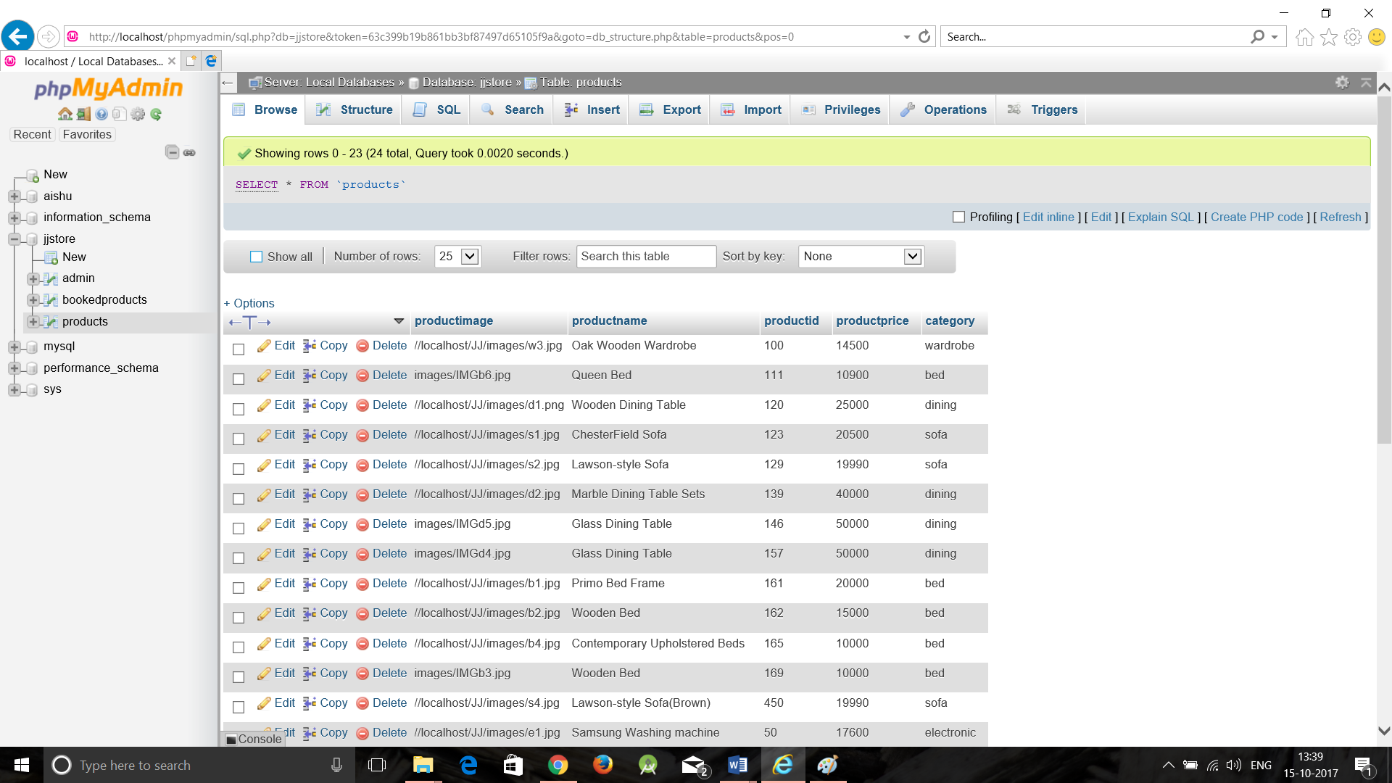

- DEPLOYMENT
Deployment diagrams are used to visualize the topology of the physical components of a system, where the software components are deployed.
They are used to describe the static deployment view of a system. Deployment diagrams consist of nodes and their relationships.
The purpose of deployment diagrams can be described as −
- Visualize the hardware topology of a system.
- Describe the hardware components used to deploy software components.
- Describe the runtime processing nodes.

DEPLOYMENT DIAGRAM:

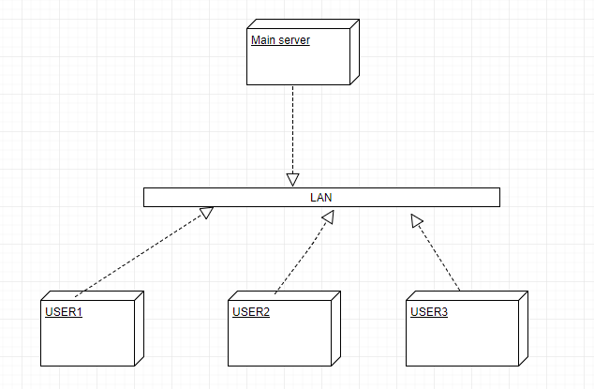

- CONCLUSION AND FUTURE ENCHANCEMENTS

Our website allows the customer to browse across various categories of furniture’s and select the products they like by viewing the image, price etc.
They can add the products into the cart and fill the details like name, email id, address and confirm booking.
The customer will receive a confirmation email.
Our future enhancement to the website would be, the user can make a booking and even make a payment for the product they buy and they can even rate the quality of the product.

BENEFITS:
- Easy to use.
- JJ furniture world is available always through internet and is accessible through web.
- Visually stunning web interface with material design flavour.

- BIBLIOGRAPHY

- The Unified Modeling Language Users guide by Grady Booch.
- Software Engineering, A practitioner’s approach by Roger S Pressman.
- Software Project Management by Walker Royce.
- http://www.w3schools.com/
- https://creately.com/
- https://secure.php.net/
- http://stackoverflow.com/

